**SCHOOL DATABASE MANAGEMENT SYSTEM**

**DBMS FA-4**

**II Year (III semester)**

*of*

**Bachelor of Technology**

in

**Computer Science & Engineering**

By:

Vanshita Kakkar

Maninder Kaur

Radhika Gupta

Dolly Gupta

Submitted to:

Mrs Inderpreet Kaur



**Chitkara University Institute of Engineering and Technology**

**Year (2020 -2024)**

**School Database Management System**

**Description of the project:**.

The project is “SCHOOL MANAGEMENT SYSTEM”. This package once developed will help school to manage various details pertaining to its students. This package is basically developed for the authorities of the school to make their task easier or we can say this package automate their tasks like maintaining students personal details, marinating cash details, printing of receipts. This package helps the administrative and accounts department in maintaining the students personal and fees related details. The basis need of this package was to automate the whole procedure of maintaining of student details, earlier it was all done manually.

The solution for all problems was to automate the system, automation of the students data maintenance would reduce the manpower, man days will result in accurate data and above all increases the efficiency of the concerned department.

**ER Diagram**

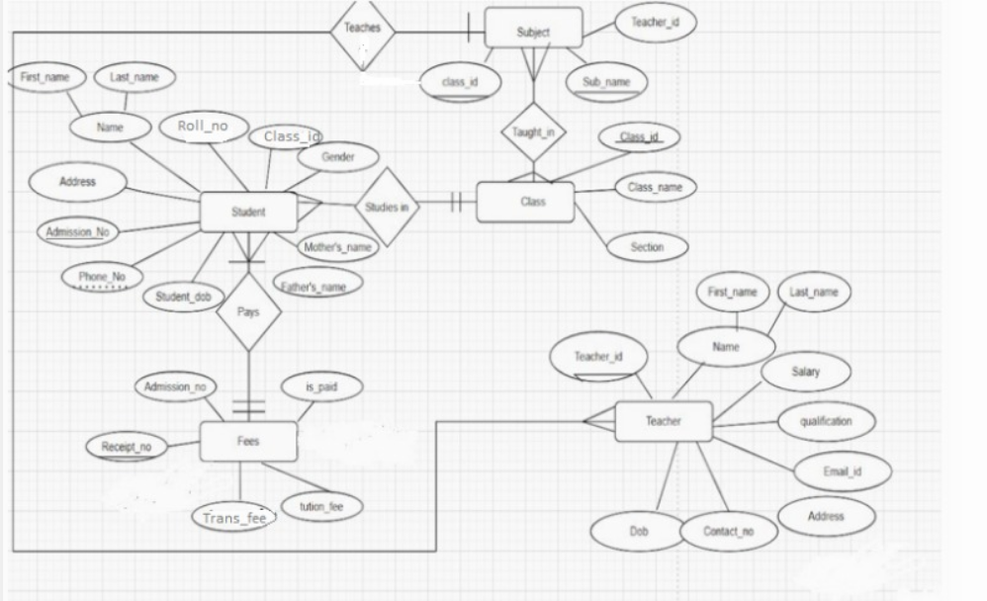

**Database**

Schema Representation After Normalisation

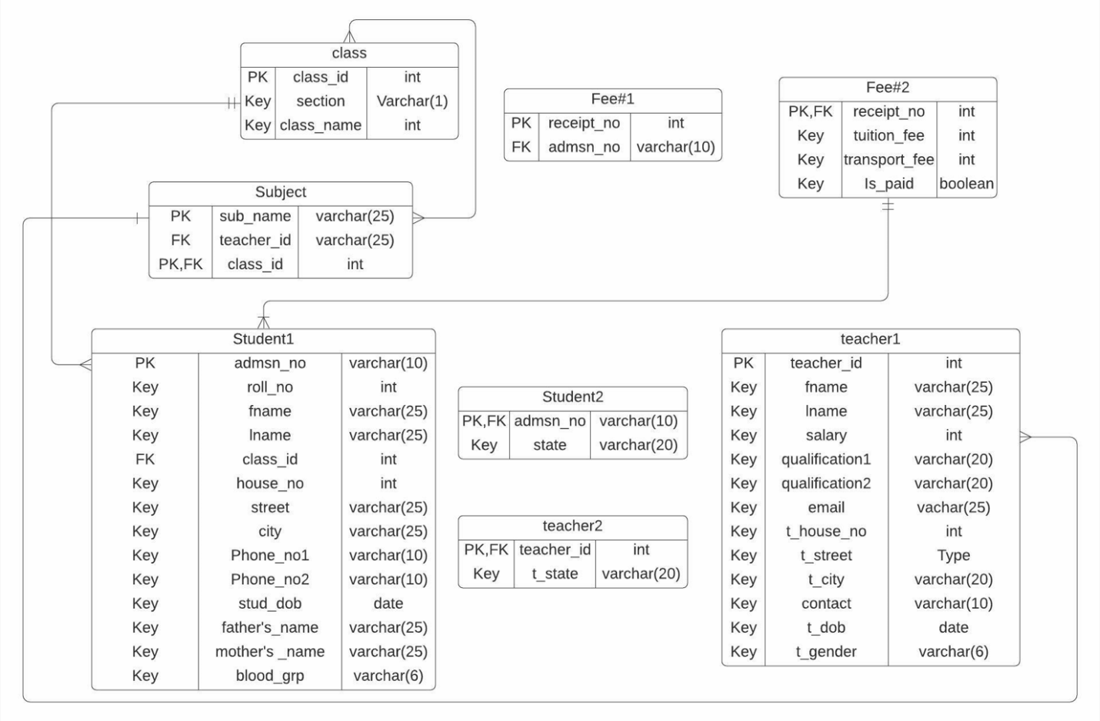

Tables

1)Class

create table class (classid int primary key ,

section varchar(1),

classname int);

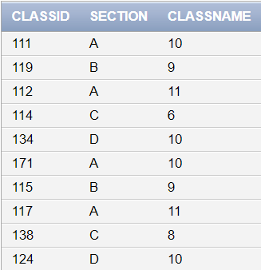

2)Student#1

create table student#1 (rollno int,

fname varchar (30)not null,

lname varchar(10) ,

classid int references class(classid),

street varchar(40),

city varchar (10),

adm_no int primary key,

father_name varchar(30),

mother_name varchar(30),

stud_dob DATE,

house_no int,

blood_grp varchar(5),

phone_no1 number(10),

phone_no2 number(10));

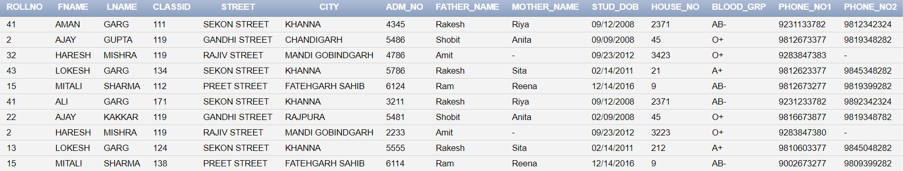

3)Student#2

create table student#2 (adm_no int references student#1(adm_no) unique,

state varchar(20));

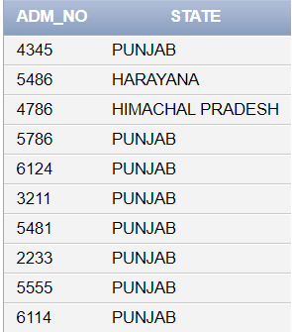

4)Fee#1

create table fee#1 (receipt_no int primary key ,

adm_no int references student#1(adm_no) unique);

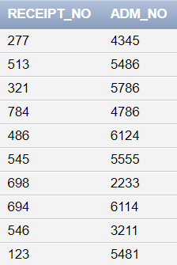

5)Fee#2

CREATE TABLE Fee#2(reciept_no int references fee#1(receipt_no) primary key,

is_paid char check (is_paid in('y','n')) ,transport_fee int,

tuition_fee int);

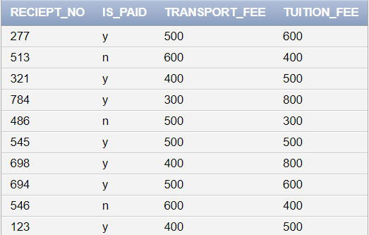

6)Teacher#1

create table teacher#1(teacher_id int primary key,

Fname varchar(30) not null,

Lname varchar(30),

salary number not null,

qualification1 varchar2(10) not null,

qualification2 varchar2(10) not null,

contact_no number(10) unique,

email_id varchar2(20) unique,

house_no int not null,

street varchar(30),

city varchar(30),

dob date not null,

gender varchar2(10) not null);

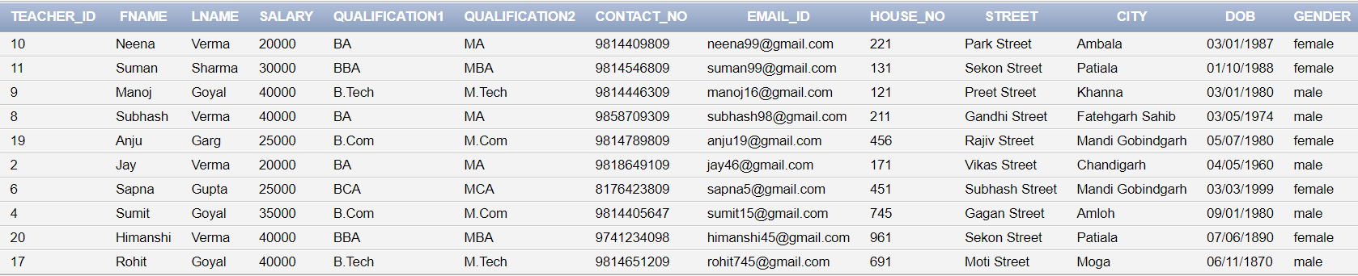

7)Subject

create table subject(sub_name varchar(10), classid int references class(classid), teacher_id int references teacher#1(teacher_id),primary key(sub_name,classid));

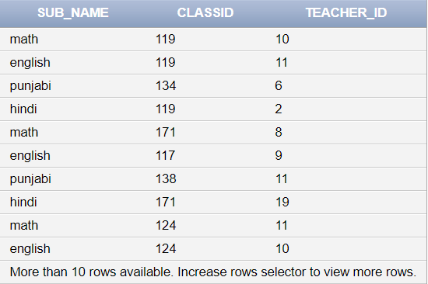

8)Teacher#2

create table teacher#2(teacher_id int references teacher#1(teacher_id) primary key, state varchar(20));

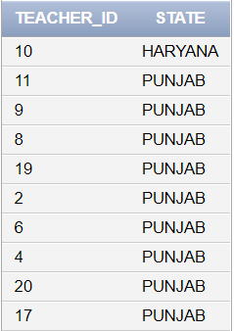

**Normalization**

**Student Table**

Student table before normalisation

|  |
| --- |
| Name |
| Roll no. |
| Class _ id |
| Phone no. |
| Address |
| Adm_ no. |
| Stud_dob |
| Father_name |
| Mother_name |
| Blood_group |

**To convert into 1NF**

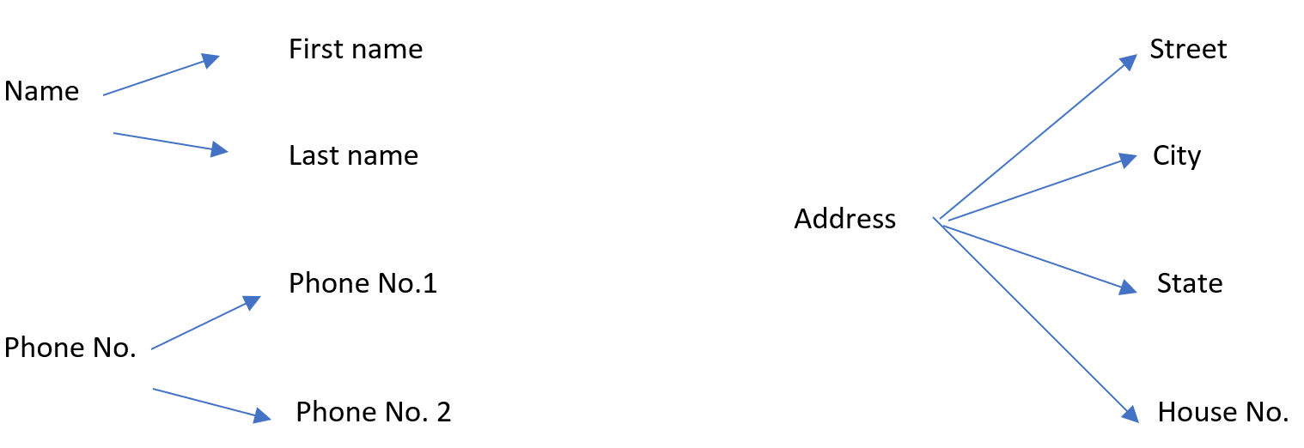

Student Table after 1NF

|  |  |
| --- | --- |
| STUDENT | |
| Roll no. | Mother name |
| Class _ id | Blood group |
| Phone no.1 | Street |
| Phone no. 2 | House _no. |
| Adm_ no. | city |
| Stud_dob | State |
| F_name | L_name |
| Father_name | Mother_name |

Now Student table is in 1NF as all the attributes has atomic values.

**TO CONVERT INTO 2NF**

**DEPENDENCIES**

Roll_no Classid ---> Fname , lname , street ,adm_no. ,phone_no.1 , phone_no.2 ,house_no mother_name, father_name , blood_grp, city.

City ---> state

Adm_no ------>roll.no class id

Candidate Key: Roll_No class_id ,adm_no

Primary Key:adm_no

There is no partial Dependency as there is no subset of any candidate key that derives non-prime attribute.

So the student table is in 2NF form.

**TO CONVERT INTO 3NF**

Adm_no → city→ state

Adm_no → state

This relation exists in the student table. So student table is not in 3NF.

So student table is decomposed into student#1 and student#2.

**STUDENT#1**

|  |  |
| --- | --- |
| Roll no. | Fname |
| Class _ id | Lname |
| Phone no.1 | Street |
| Phone no.2 | Father_name |
| Adm_ no. **PK** | City |
| Stud_dob | House no. |
| Blood_group | Mother_name |

**Student#2**

|  |
| --- |
| Adm_no **PK,FK** |
| State |

**DEPENDENCIES AFTER DECOMPOSITION OF STUDENT TABLE**

Student#1

Roll_no Classid ---> Fname , lname , street ,adm_no. ,phone_no.1 , phone_no.2 ,house_no mother_name, father_name , blood_grp, city.

Adm_no ------>roll.no class id

Student#2

Adm_no-->state

**BCNF :**

As in all functional dependencies, there is candidate key on left hand side.So student#1 and student#2 are in BCNF.

**FEE TABLE :**

**Fee**

|  |
| --- |
| Receipt_no **PK** |
| Adm_no **FK** |
| tuition_fee |
| transport_fee |
| is_paid |

**TO CONVERT INTO 1NF**

Fee table is in 1NF because all the attributes of fee have atomic values so there’s no need to further bifurcate the attributes, multivalued attributes are not in picture.

**TO CONVERT INTO 2NF**

**Dependencies :**

receipt_no adm_no

adm_no is_paid, transport_fee, tuition_fee

Candidate key = receipt_no = Primary Key

As the candidate key is singleton candidate key, so imagining a partial dependency is meaningless that’s why the table is in 2NF.

**TO CONVERT INTO 3NF**

receipt_no adm_no is_paid, transport_fee, exam_fee, tuition_fee

receipt_no is_paid, transport_fee, exam_fee, tuition_fee

The existence of the above written dependency makes the table to not be in 3NF that’s why the following bifurcation is provided :

|  |
| --- |
| **Fee#1** |
| receipt_no **PK** |
| adm_no **FK** |

|  |
| --- |
| **Fee#2** |
| receipt_no **PK,FK** |
| is_paid |
| transport_fee |
| tution_fee |

The transitivity has been eliminated and thus the tables are in 3NF.

**DEPENDENCIES**

**Fee#1 :**

reciept_no adm_no

**Fee#2 :**

receipt_no is_paid, transport_fee, exam_fee, tuition_fee

**BCNF :**

As in all functional dependencies, there is candidate key on left hand side.So Fee#1 and Fee#2 are in BCNF.

**Teacher Table :**

**Teacher**

|  |
| --- |
| teacher_id **PK** |
| teacher_name |
| salary |
| qualification |
| email_id |
| address |
| contact_no |
| t_dob |
| gender |

**TO CONVERT INTO 1NF**

f_name

teacher_name

l_name

house_no

Address street

city

state

qualification1

Qualification

qualification2

|  |
| --- |
| **Teacher** |
| teacher_id **PK** |
| f_name |
| l_name |
| salary |
| qualification1 |
| qualification2 |
| contact_no |
| street |
| email_id |
| house no |
| city |
| state |
| dob |
| gender |

1NF has been achieved.

**Dependencies :**

teacher_id f_name, l_name, salary, contact_no, gender, dob, qualification1, qualification2 ,email_id, city

email_id contact_no, teacher_id

contact_no email_id

city state

**2NF :**

**DEPENDENCIES**

Candidate Key :Contact_no, email_id, teacher_id

Primary Key : teacher_id

As the candidate key is singleton candidate key so there is no meaning for partial dependencies. Teacher table is in 2NF.

**3NF :**

teacher_idcitystate

teacher_idstate

The above mentioned relations are transitive in nature thus it leads to the violation of 3NF form. The following bifurcation will end this transitivity and thus leading to the proper 3NF form.

|  |
| --- |
| **Teacher#1** |
| teacher_id **PK** |
| f_name |
| l_name |
| salary |
| qualification1 |
| qualification2 |
| contact_no |
| email_id |
| city |
| dob |
| house_no |
| street |
| gender |

|  |
| --- |
| **Teacher#2** |
| teacher_id **PK** |
| state |

3NF form has been achieved.

**DEPENDENCIES AFTER 3NF:**

**Teacher#1**

teacher_id f_name, l_name, salary, contact_no, gender, dob, qualification1, qualification2 ,email_id, city

email_id contact_no, teacher_id

contact_no email_id

**Teacher#2**

teacher_id state

**BCNF :**As in all functional dependencies, there is candidate key on left hand side.So Fee#1 and Fee#2 are in BCNF.

____________________________________________________________

**SUBJECT TABLE**

|  |
| --- |
| **Subject** |
| Sub_name  **PK** |
| Class_id **PK,FK** |
| teacher_id **FK** |

**1NF :** Subject table is already in 1NF as there is absency of multivalued attributes and atomic states of all the attributes are present in the table.

**Dependencies :**

Sub_name class_id teacher_id

Candidate Key = Sub_name, Class_id = Primary Key

**2NF :** There is no partial Dependency as there is no subset of any candidate key that derives non-prime attribute.

**3NF :** There is no transitivity as well so the table is already in 3NF.

**BCNF :**As in all functional dependencies, there is candidate key on left hand side.So Subject table is in BCNF.

____________________________________________________________

**Class Table**

|  |
| --- |
| **Class** |
| class_id **PK** |
| section |
| class_name |

**Dependencies :**

Class_id section, class_name

Candidate Key = Class_id = Primary Key

The fact that the table is in BCNF eliminates the need to check for lower normal forms.

**Queries**

1)Find fname ,lname ,teacher_id of teacher whose salary is greater than 20,000 but less than 35000

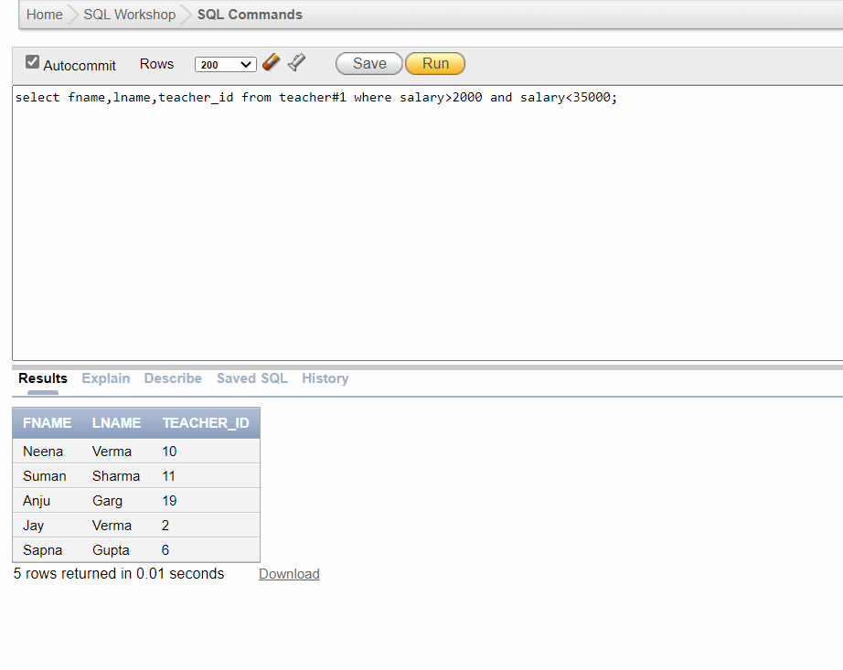

2)Find out number of students in class which have classid=119

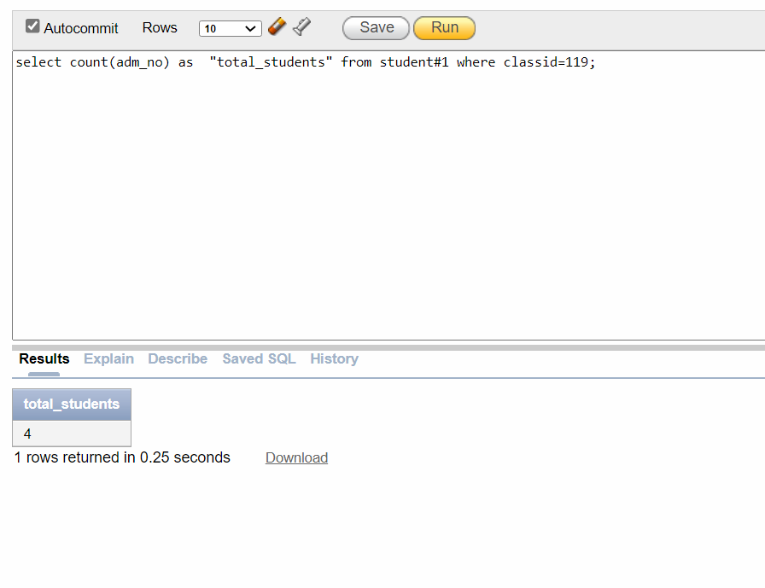

3)Find out the teacher name who teaches hindi to class having classid=119.

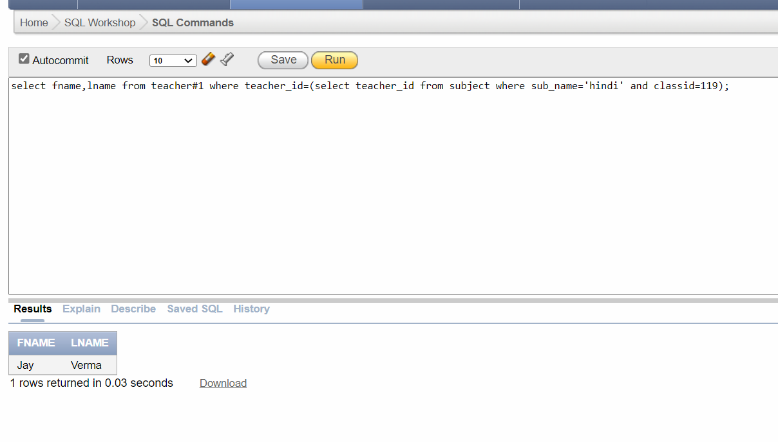

4)Update the class name which has classid 114.

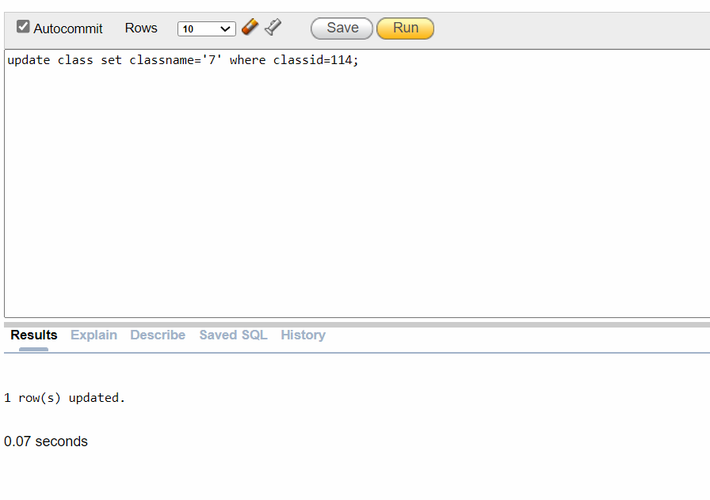

5)Add science subject in class having class_id 119 and teacher with teacher_id 8 teaches.

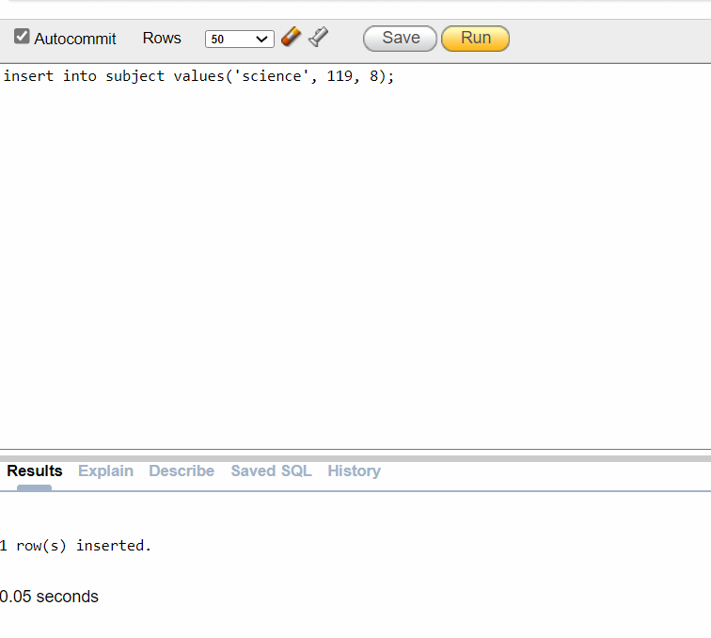

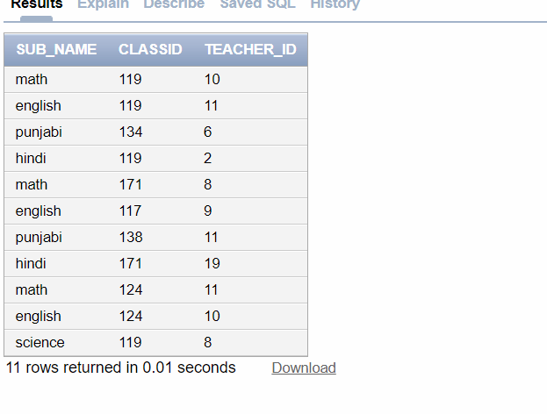

6) Find the students’ admission no who have receipt no 513,321,698.

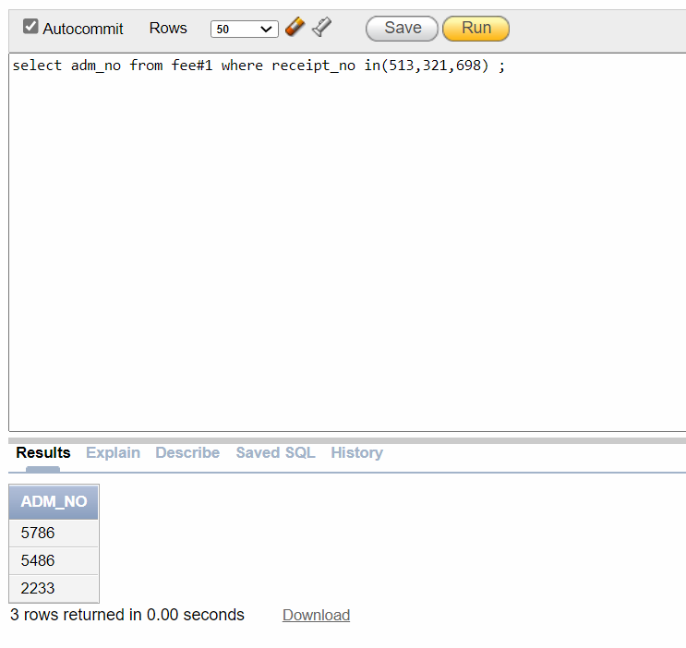

7) Find max and min salary of teacher.

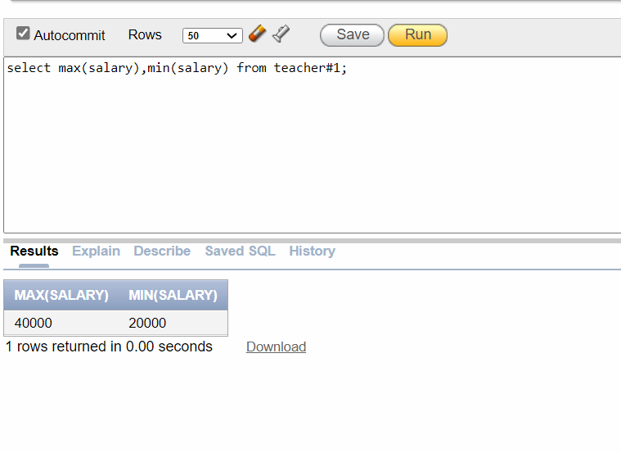

8)Find all details of all students.

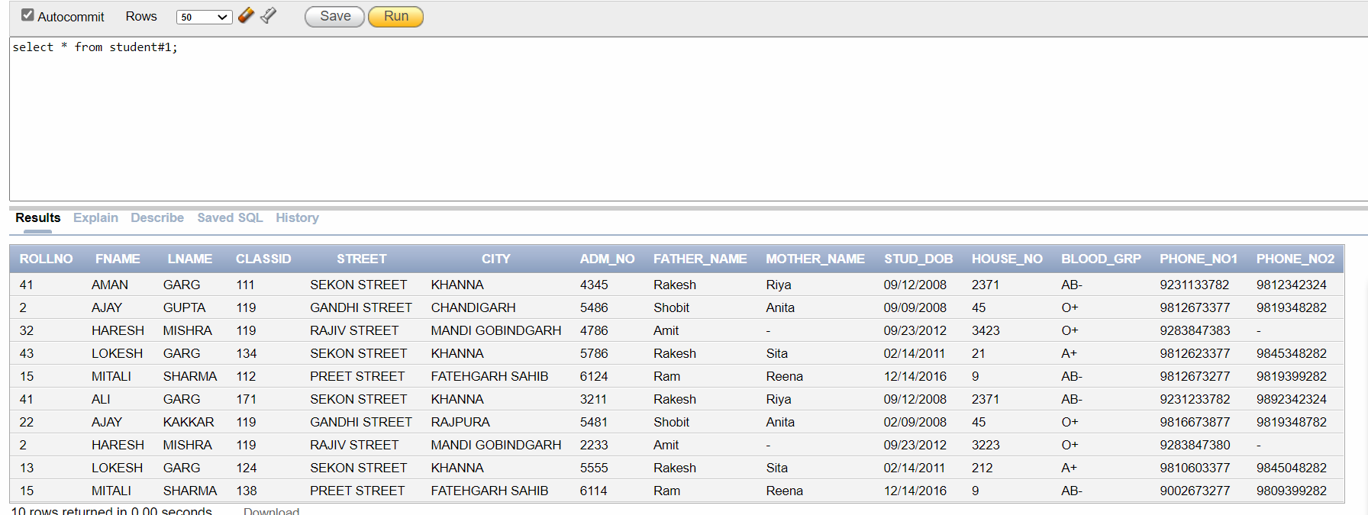

**Work division table**

|  |  |
| --- | --- |
| **Student Name** | **Work done** |
| **Vanshita Kakkar** | **Normalization, Queries** |
| **Maninder Kaur** | **Schema Representation,Queries** |
| **Radhika Gupta** | **ER Diagram,Queries** |
| **Dolly Gupta** | **ER Diagram, Tables** |